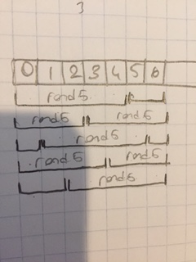

Call Rand5 for 7 times with shifted values of (0, 5, 3, 1, 6, 4, 2) so each int from 0 to 7 gets equal chance